Milestone 3 – UML Diagram

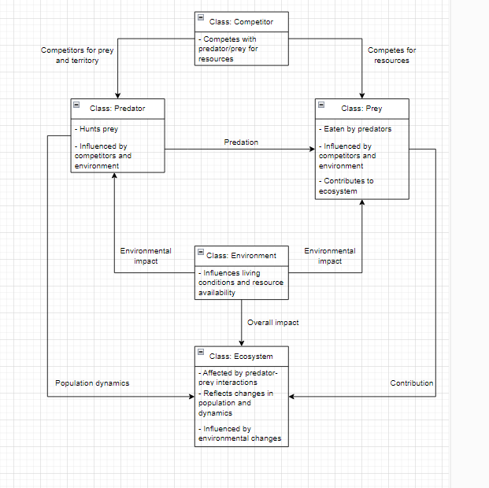

# Design Documentation

This diagram represents complex interactions within an ecosystem. By including entities such as predators, prey, competitors, and the environment. This showcases their relationships and helps us understand how these entities interact and impact one another.

* Predator: Represents the species that hunt and consume other organisms.
* Prey: Represents the species that is hunted and consumed by predators.
* Competitor: Represents other species that compete with the predator or prey for resources.
* Environment: Represents factors that influence living conditions and resource availability within the ecosystem.
* Ecosystem: Represents the overall ecological system, reflecting the interactions and relationships among predator, prey, and environmental components.

Within an ecosystem, predators hunt and consume prey, affecting the population. This can influence the overall ecosystem by regulating said populations. Prey contributes to the ecosystem by serving as a food source and participating in other ecological interactions. Competitors compete for resources between predators and prey, depending on the type of competitor introduced to the ecosystem. The environment can affect both the predator and prey populations with certain change4s within it, such as climate change or habitat destruction. These types of changes can impact the ecosystem’s health and stability.